MANKAR COLLEGE
Macroeconomics (2nd Semester)

Macroeconomics: Macroeconomics is that branch of positive economics which deals with the basic problem of economics from aggregate standpoint or by taking the unit as a whole. It contains the study of the aggregated concepts like National Income (NI), Gross Domestic Product (GDP), Unemployment, Aggregate Demand, Aggregate Supply etc.
Objectives: The basic objective of Macroeconomics is the Economic Growth of the nation. This growth can be achieved by achieving the following goals -
- Reduction in the unemployment rate.
- Stabilizations of the prices in the economy.
- Maintaining the balance of payments.
- Stabilizing the economic growth rate.
Variables (Income & Expenditure): Both output and income are interchangeably used in macroeconomics. Income is generally directly proportional to the level of output an economy produces. This GDP is used in the measurement of the efficiency of economy’s function. In the other way, income is a net total of the flow of payments received in a given time period. Hence, output can be measured by calculating the total income from the sale of all goods and services.
On the other hand, aggregate expenditure is the current value of all the finished goods and services in the economy. It is the sum of all the expenditures undertaken in the economy by the factors during a specific time period. The equation is –
Aggregate Expenditure (AE) = C+I+G+NX Where,
C = Consumption (The household consumption over a period of time.)
I = Investment (The amount of expenditure towards the capital goods.)
G = Government Spending (The amount of spending by federal, state and local government.)
NX= Net Export (Total exports - total imports.)
The aggregate expenditure is one of the methods that are used to calculate the total sum of all the economic activities in an economy, also known as GDP.
Equilibrium: Equilibrium is a state of balance between two opposite forces, i.e. when the two opposite forces are equal in strength. Basically there are two varieties of equilibrium - Static and Dynamic.
Static: The Static analysis focuses on a particular situation, a particular equilibrium, without referring to the other factors and time. When two different equilibrium situations are compared due to a change in any variable, then such analysis is called comparative static analysis.
In comparative static analysis one static equilibrium positions is compared with another static equilibrium. In static equilibrium analysis there may be several parameters which are assumed to remain constant at certain levels. If any of these parameters changes the equilibrium position will change. When we compare one equilibrium position with another corresponding to two different values of one parameter, we adopt comparative static analysis. The Keynesian multiplier analysis is an example of comparative static analysis. The simple Keynesian model has three equations: the consumption function C = C(Y), the investment function I = I₀ and the equilibrium condition Y = C+I. In these three equations there are three unknowns: Y, C and I. solving these three equations we can get the equilibrium values of all these three variables. This analysis is static because all the variables refer to the same period of time. But, it does not concern itself with the time it takes for an equilibrium position to be achieved, nor with the path by which variable approach their equilibrium state. This is one concern of Dynamic analysis.
Equilibrium and Stability: Suppose, D = f(P) is the demand function and S = f(P) is the supply function where, dD/dP<0 and dS/dP>0. This means that demand varies inversely with price (which is known as the Law of Demand) and this makes the demand curve downward sloping; on the other hand, supply of any good is a positive function of its price (known as Law of Supply) and this make the supply curve upward sloping. Now, equilibrium will exist, if demand equates supply at any positive price and quantity. If E is the excess demand, then E = D(P) - S(P)
Or, E = D(P) – S(P) = 0
Or, D(P) = S(P) where, P>0.
This means that at any positive price (and quantity), demand equals supply and excess demand is 0, so equilibrium will exist. Consider the following figure-
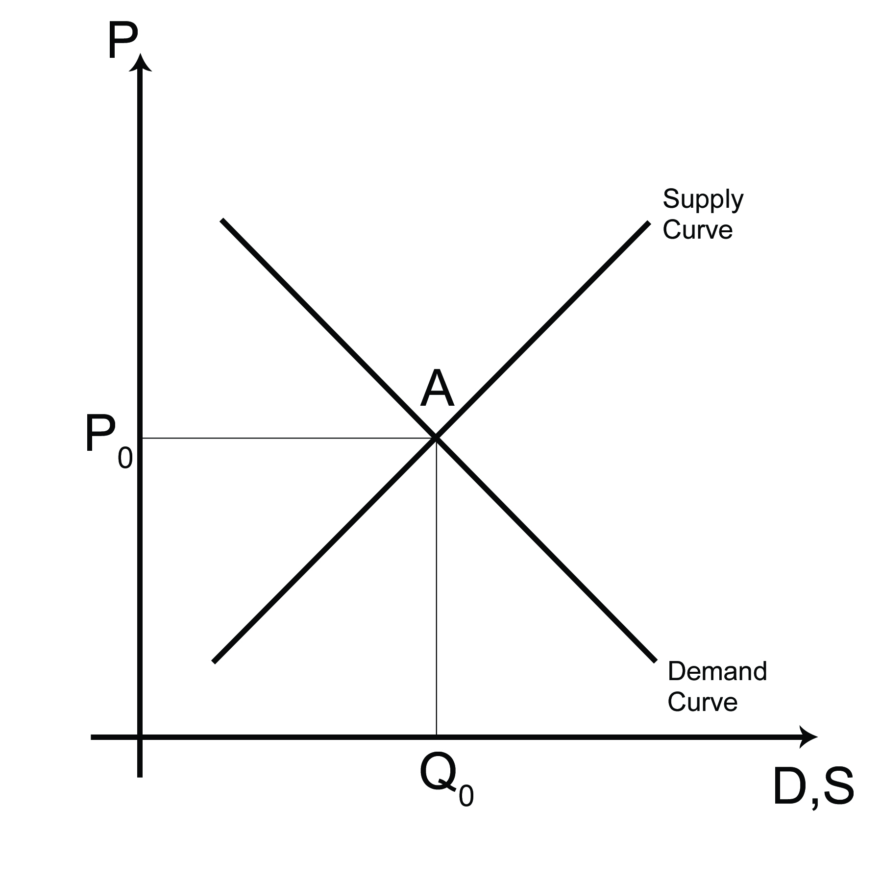
In the figure beside, demand and supply equates at point A, at a positive price P₀ and positive quantity Q₀. Thus, A is the equilibrium point.
The equilibrium at A is also a stable equilibrium. There are two approaches of measuring stability: a) Walrasian stability, b) Marshallian stability.
According to Walrasian stability approach, equilibrium will ber stable if excess demand varies inversely with price, i.e. E = D(P) - S(P)
For Walrasian stability, we require dE/dP <0 i.e. dE/dP = dD/dP - dS/dP <0
Or, dD/dP< dS/dP
This shows that equilibrium will be stable if the slope of demand curve is less than slope of supply curve.
In terms of Marshallian approach, equilibrium will be stable if excess demand price (E´) inversely with quantity (Q). Where Eَ = P(Q) – S(Q).
The stability requires dE´/dQ<0. Where dE´/dQ = dP/dQ – dS/dQ <0
Or, dP/dQ<dS/dQ
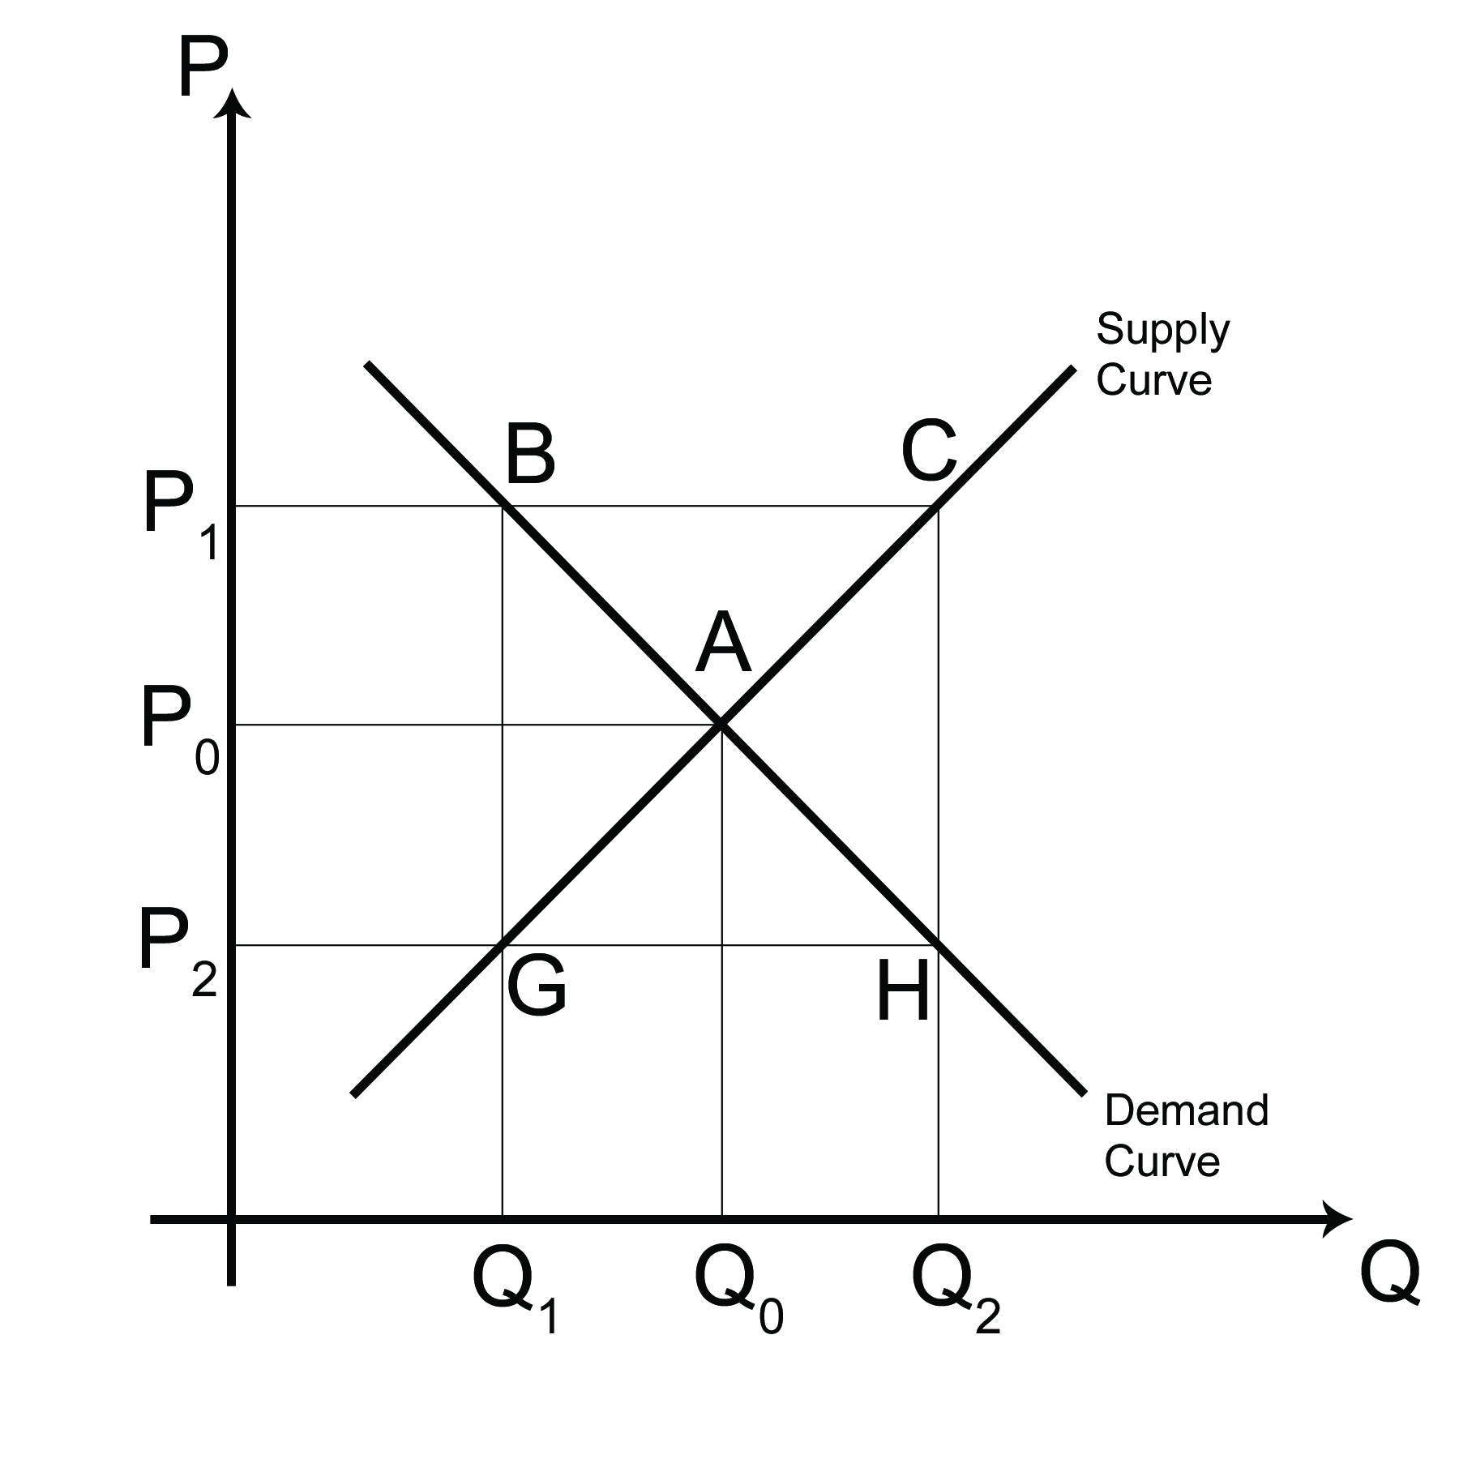
This means that equilibrium will be stable if the slope of the demand curve is less than slope of supply curve. Consider the following figure-

In the figure beside, A represents equilibrium point. At price P_{1,} there is excess supply by the amount BC, so P₁ falls; at price P₂, there is excess demand, so P₂ rises and P₀ is stable in terms of Walrasian approach. Again at quantity Q_{1,} there is positive excess demand price by GB, so Q₁ rises and at Q₂, there is excess supply price CH, so Q₂ falls. Thus Q₀ is stable in terms of Marshallian approach.

National Income Accounting Analysis and Circular Flow of Income:
National Income is defined as the money value of all goods produced and services generated in an economy during a particular period of time. If only the activities in the domestic economy are considered, then it is Gross Domestic Product (GDP) and when we also include the foreign transaction, it becomes Gross National Product (GNP).
In a simplified economy, consisting of two sectors; household (H) and firms (F), national income moves in a circular way from one end to other. To examine this circular flow of income we make the following assumptions-
- All consumption expenditure is made by households,
- All investment expenditure is made by firms or enterprises.
- The economy is laissez faire.
- The economy is closed.
On the basis of these assumptions it can be seen that the National Income (NI) originates from firm, goes to the household and again flows back to the firm. The household possess factors like land (S), labor (L) and capital (C) which they supply to the firm in exchange of some payments like wage (w), rent (r) and profit (p); for labor ,land and capital respectively. These are the factor income on the part of the household and factor cost on the part of the firm. This is the source of the NI.
Thus, NI = w+r+p ……………… (1)
The firm produces goods with these factors and the result is a flow of goods and services on the market which are purchased by the households in exchange of money. The expenditure by the households results in a flow of income from the household to the firm. The total volume of goods produced and sold can be split into two parts: Consumer goods (C) and Investment goods (I). The money value of all goods produced is the National Product and the total expenditure on them is the National Expenditure. Thus, households purchase the goods produced by the firms with the income they had received from firms. Therefore, we can write-
National Output = C+I
= National Expenditure
= w+r+p
= National Income
Or, we can also write,
National Income = National Output = National Expenditure.
This is what is called the fundamental identity of National Income Accounting Analysis. This also shows that there are three basic methods of measuring the National Output of a country; it is either by summing over the money value of all goods (product method), or by summing over all incomes (income method), or by summing over all expenditure (expenditure method).
A part of the NI is consumed (C) and a part is saved (S).
Thus, NI = w+r+p = C+S.
Therefore, National Expenditure (NE) = C+I and NI = C+S.
Since, NI = NE
Or, C+S = C+I
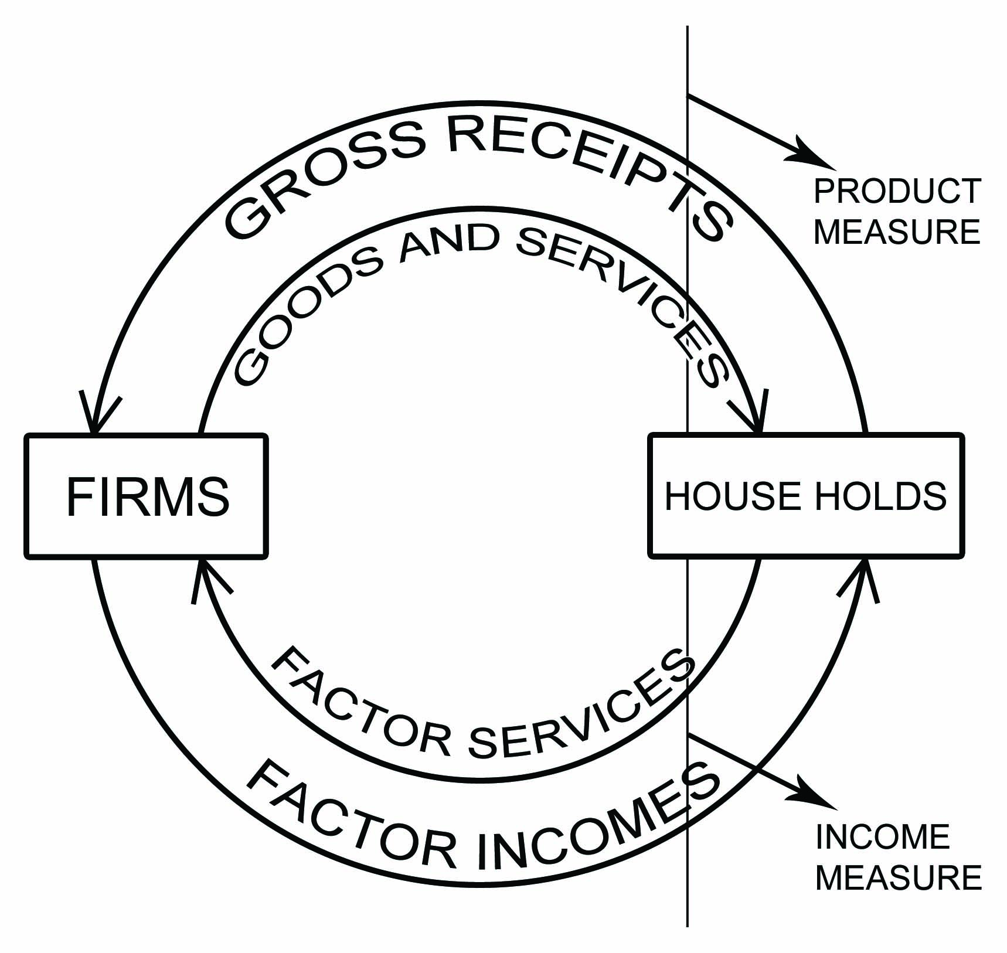
Or, S = I.
This shows that actual saving and actual investment are always equal, by definition. This saving and investment refers to the ex-post magnitude, but not ex-ante. It has nothing to do with the equilibrium level of income. But, the quantity of ex-ante saving and investment is a condition for the equilibrium of NI.
The process of the circular flow of income can be explained in terms of the following circuit diagram-
In the circuit beside, it is seen that households sell factors to farms and we get factors flow, which enters into firm who produces goods; a part of which goes to household as consumers goods and a part goes to firm as investment good, through commodity market. The household holds spent a part of their income on consumer goods, and the remaining part is saved which goes to firm as investment through money market. This investment fund is used to purchase investment goods and the money comes to the market as investment expenditure, which together with consumption expenditure make up. National expenditure which is going to the firm as their income which is again split for the payment to the three factors and the circulation process enters into the next period. Thus a given sum of money starts generating from firm, goes to household, and again comes back to firm. Out of the three factors income, wage, rent are contractual; whereas profit is the residual. This means that,
Profit = National Output-(wage+rent).
Let us now examine the assumption of closed economy and we assume that the economy participates in international trade, i.e. the economy is opened. In an open economy, the country sells something to abroad, known as exports (X) and purchases from abroad, imports (N). In that case the NI accounting identity becomes:
On product side we have, Gross National Product (GNP) ≡ C+I+G+(X-N)
On income side we have, Gross National Income (GNI) ≡ C+I+G+(X-N)
On expenditure side we have, Gross National Expenditure (GNE) ≡ C+I+G+(X-N)
Therefore, GNP ≡ GNI ≡ GNE ≡ C+I+G+(X-N)
It is to be noted that the measurement of NI in case of closed economy; we adopt a concept of domestic, i.e. GDP, GDI, GDE. And in case of open economy only it becomes GNP, GNI, and GNE. Further in the production process, there is some natural loss or wear & tear or depreciation (D). And volume depreciation is deducted and we get the net value, i.e. GNP - D ≡ NNP (Net National Product)
GNI - D ≡ NNI (Net National Income)
GNE - D ≡ NNE (Net National Expenditure)
It is to be noted that in valuing the National Product, there is a problem of double counting due to the presence of intermediate product. To avoid this problem of double counting, a method is used, known as value added method.
Where, value added = value of sales-value of purchase.

PRIYATOSH ROY
Department of Economics
Mankar Cllege

